**Swag Labs:**

Bugs by Manually tested:

1. Don’t show name of the sticker, plus error msg should be clear.  
   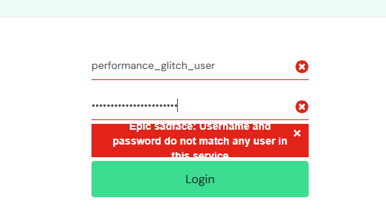
2. Cursor should be pointer on the hover over the cart button not arrow.
3. While pointing on dropdown icon at filter, dropdown menu should be open. Now, it is just opened at filter icon and filter text, not on dropdown icon.  
   Point 2 and 3 shown in point 5th gif.
4. How to add more than 1 item of any product?
5. On “Reset App State”, all items removed from cart but the button is not updated to “add to cart”. See gif  
   
6. Disable “Checkout” button if no item in the cart. + restrict only number in the zip/postal code field in the form.

